

QUEENSLAND COUNTRY CRICKET

MEMBER PROTECTION POLICY

Updated 2023

CONTENTS PAGE

POLICY
- Introduction
- Purpose of Our Policy
- Who Our Policy Applies To
- Extent of Our Policy
- Club Responsibilities
- Individual Responsibilities
- Protection of Children
  - Child Protection
  - Supervision
  - Transportation
  - Taking Images of Children
- Discrimination, Harassment and Bullying
- Inclusive Practices
- Responding to Complaints
  - Complaints
  - Complaint Handling Process
  - Disciplinary Measures

Attachment 1: Employment screening / working with children check requirements

1A Volunteer/employment screening/working with children requirements

1B Member Protection Declaration

1C Working with Children Check Requirements

Attachment 2: Codes of Behaviour

Attachment 3: Duty Statements

[you may want to include duty statements for positions such as coaches, team managers, officials, president, etc]

Attachment 4: Procedure for handing allegations of child abuse

Attachment 5: Reporting Requirements and Documents

Attachment 6: Child and Youth Risk Management Strategy Checklist

QUEENSLAND COUNTRY CRICKET INC.

MEMBER PROTECTION POLICY

___________________________________________________________

1. Introduction

To foster, develop, promote and manage the game of cricket in the Queensland Country Cricket Association (which shall mean and include all areas in the State of Queensland outside of the Brisbane Metropolitan area).

2. Purpose of Our Policy

The main objective of our Member Protection Policy (“policy”) is to maintain responsible behaviour and the making of informed decisions by members and other participants in this club. It outlines our commitment to a person’s right to be treated with respect and dignity, and to be safe and protected from discrimination, harassment and abuse. Our policy informs everyone involved in our club of his or her legal and ethical rights and responsibilities and the standards of behaviour that are expected of them. It also covers the care and protection of children participating in our club’s activities.

3. Who Our Policy Applies To

This policy applies to everyone involved in the activities of our club whether they are in a paid or unpaid/voluntary capacity and including:

- club committee members, administrators and other club officials;
- coaches and assistant coaches and other personnel participating in events and activities, including camps and training sessions;
- support personnel, including managers, physiotherapists, psychologists, masseurs, sport trainers and others;
- referees, umpires and other officials;
- athletes;
- members, including any life members;
- parents;
- spectators; and [any other person to whom the policy may apply].

4. Extent of Our Policy

Our policy covers all matters directly and indirectly related to the Queensland Country Cricket Association and its activities. In particular, the policy governs unfair selection decisions and actions, breaches of our code of behaviour and behaviour that occurs at training sessions, in the club rooms, at social events organised or sanctioned by the club (or our sport), and on away and overnight trips. It also covers private behaviour where that behaviour brings our club or sport into disrepute or there is suspicion of harm towards a child or young person.

5. Club Responsibilities

We will:
- adopt, implement and comply with this policy;
- ensure that this policy is enforceable;
- publish, distribute and promote this policy and the consequences of any breaches of this policy;;
- promote and model appropriate standards of behaviour at all times;
- deal with any complaints made under this policy in an appropriate manner;
- deal with any breaches of this policy in an appropriate manner;
- recognise and enforce any penalty imposed under this policy;
- ensure that a copy of this policy is available or accessible to all people and organisations to whom this policy applies;
- review this policy every 12-18 months; and
- seek advice from and refer serious issues to our Queensland Cricket.

Serious issues include unlawful behaviour that involves or could lead to significant harm and includes criminal behaviour (e.g. physical assault, sexual assault, child abuse) and any other issues that our state or national bodies request to be referred to them.

6. Individual Responsibilities

Everyone associated with our club must:
- make themselves aware of the contents of this policy;
- comply with all relevant provisions of this policy, including the standards of behaviour outlined in this policy;
- consent to the screening requirements set out in this policy, and any state or territory Working with Children checks if the person holds or applies for a role that involves regular unsupervised contact with a child or young person under the age of 18, or where otherwise required by law;
- treat other people with respect;
- always place the safety and welfare of children above other considerations;
- be responsible and accountable for their behaviour; and
- follow the guidelines outlined in this policy if they wish to make a complaint or report a concern about possible child abuse, discrimination, harassment, bullying or other inappropriate behaviour; and
- comply with any decisions and/or disciplinary measures imposed under this policy.

7. Protection of Children

7.1 Child Protection

The Queensland Country Cricket Association is committed to the safety and wellbeing of children and young people who participate in our clubs’ activities or use our services. We support the rights of the child and will act at all times to ensure that a child safe environment is maintained. We also support the rights and wellbeing of our staff and volunteers and encourage their active participation in building and maintaining a secure and safe environment for all participants.

Queensland Country Cricket Association acknowledges the valuable contribution made by our volunteers, members and staff. We encourage their active participating in providing a safe, fair and inclusive environment for all participants.

7.1.1: Identifying and Analysing Risks of Harm

The Queensland Country Cricket Association will develop and implement a risk management strategy, contained in attachment 6, which includes a review of our existing child protection practices, to determine how child-safe our organization is and to identify any additional steps we can take to minimize and prevent the risk of harm to children because of the action of an employee, volunteer or another person.

7.1.2: Developing Codes of Conduct for Adults and Children

We will develop and promote a code of conduct that specifies standards of conduct and care we expect of adults when they deal and interact with children, particularly those in our care. We will also implement a code of conduct to promote appropriate behaviour between children.

The codes will clearly describe professional boundaries, ethical behaviour and unacceptable behaviour. (See Attachment 2)

7.1.3: Choosing Suitable Employees and Volunteers

The Queensland Country Cricket Association will ensure that the organization takes all reasonable steps to ensure that it engages the most suitable and appropriate people to work with children, especially those in positions that involve regular unsupervised contact with children .This may be achieved using a range of screening measures. Such measures will aim to minimize the likelihood of engaging (or retaining) people who are unsuitable to work with children.

The Queensland Country Cricket Association will ensure that Working with Children Checks and criminal history assessments are conducted for employees and volunteers working with children, where an assessment is required by law. If a criminal history report is obtained as part of the screening process, the Queensland country Cricket Association will ensure that the criminal history information is dealt with confidentially and in accordance with relevant legal requirements. (See Attachment 1.3)

http://www.bluecard.qld.gov.au/risk-management.html

7.1.4: Support, Train, Supervise and Enhance Performance

The Queensland Country Cricket Association will ensure that all our employees and volunteers who work with children have ongoing supervision, support and training. Our goal is to develop their skills and capacity and to enhance their performance so we can maintain a child-safe environment in our club.

7.1.5: Empower and Promote the Participation of Children In Decision-Making And Service Development

The Queensland Country Cricket Association will promote the involvement and participation of children and young people in developing and maintaining a child-safe environment in our club.

7.1.6: Report and Respond Appropriately to Suspected Abuse and Neglect

The Queensland Country Cricket Association will ensure that employees and volunteers are able to identify and respond appropriately to children at risk of harm and that they are aware of their responsibilities under state laws to make a report if they suspect on reasonable ground that a child has be, or is being, abused or neglected (See Attachment 4).

In addition to any legal obligations, if any person believes that another person or organization bound by this policy is acting inappropriately towards a child or is in breach of this policy they may make an internal complaint.

Please refer to our complaints procedure in section 10 of this policy.
Any person who believes a child is in immediate danger or in a life-threatening situation, should contact the police immediately.

7.2 Supervision

We endeavour to always provide an appropriate level of supervision. If a member finds a child under the age of [18] is unsupervised, if possible, they should assume responsibility for the child’s safety until the child’s parent/guardian or supervisor is located.

For reasons of courtesy and safety, parents must collect their children on time. If it appears a member will be left alone with just one child at the end of any club activity, they will ask another member to stay until the child is collected.]

  - Transportation

Parents and or guardians are responsible for organising the transportation of their children to and from club activities (e.g. training and games).

7.4 Taking Images of Children
Images of children cannot be used inappropriately or illegally. We require that members, wherever possible, obtain permission from a child’s parent or guardian before taking an image of a child that is not their own. We will also make sure that the parent or guardian understands how the image will be used.
When using a photo of a child, we will not name or identify the child or publish personal information, such as residential address, email address or telephone number, without the consent of the child’s parent or guardian. We will not provide information about a child’s hobbies, interests, school or the like, as this can be used by paedophiles or other persons to “groom” a child.
We will only use images of children that are relevant to our associations activities and we will ensure that they are suitably clothed in a manner that promotes our club. We will seek permission from a child’s parent or guardian before using their images.

8. Discrimination, Harassment and Bullying

Our associations is committed to providing an environment in which people are treated fairly and equitably and that is, as far as practicable, free from all forms of discrimination, harassment and bullying.

We recognise that people may not be able to enjoy themselves or perform at their best if they are treated unfairly, discriminated against, harassed or bullied.

We expect all members to abide by the Queensland Country Cricket Association, Queensland Cricket and Cricket Australia Codes of Behaviour.

- Inclusive Practices

Our association is welcoming, and we will seek to include members from all areas of our community.

10. Responding to Complaints
[Note: Clubs must ensure that this procedure accurately reflects the rules and procedures in their constituent documents, rules, regulations or by-laws and that such documents enable them to take the disciplinary actions contemplated in these sections.]

10.1 Complaints

Our club takes all complaints about on and off-field behaviour seriously. Our club will handle complaints based on the principles of procedural fairness, and ensure:
- all complaints will be taken seriously;
- the person making the complaint (complainant) will be given full details of what is being alleged against them and have the opportunity to respond to those allegations;
- irrelevant matters will not be taken into account;
- decisions will be unbiased; and
- any penalties imposed will be reasonable.

If the complaint relates to suspected child abuse, sexual assault or other criminal activity, then our club will need to report the behaviour to the police and/or relevant government authority.

10.2 Complaint Handling Process

When a complaint is received by our club, the person receiving the complaint (e.g. President, Member Protection Information Officer) will:
- listen carefully and ask questions to understand the nature and extent of the concern;
- ask what the complainant how they would like their concern to be resolved and if they need any support;
- explain the different options available to help resolve the complainant’s concern;
- inform the relevant government authorities and/or police, if required by law to do so; and
- where possible and appropriate, maintain confidentiality but not necessarily anonymity.

Once the complainant decides on their preferred option for resolution, the club will assist, where appropriate and necessary, with the resolution process. This may involve:

At any stage of the process, a person can seek advice from an anti-discrimination commission or other external agency and, if the matter is within their jurisdiction, may lodge a complaint with the anti-discrimination commission or other external agency.

10.3 Disciplinary Sanctions

OUR CLUB MAY TAKE DISCIPLINARY ACTION AGAINST ANYONE FOUND TO HAVE BREACHED OUR POLICY OR MADE FALSE AND MALICIOUS ALLEGATIONS, ANY DISCIPLINARY MEASURE IMPOSED UNDER OUR POLICY MUST:

BE APPLIED CONSISTENT WITH ANY CONTRACTUAL AND EMPLOYMENT RULES AND REQUIREMENTS;

BE FAIR AND REASONABLE;

BE BASED ON THE EVIDENCE AND INFORMATION PRESENTED AND THE SEARIOUSNESS OF THE BREACH; AND
- BE DETERMINED BY OUR CONSTITUENT DOCUMENTS, by LAWS AND THE RULES OF THE GAME.

Attachment 1: WORKING WITH CHILDREN CHECK REQUIREMENTS

Queensland Country Cricket Association is committed to providing a child-safe environment. Queensland Country Cricket Association will recruit staff and volunteers who do not pose a risk to children.

Employment screening and Working with Children Checks can involve criminal history checks, signed declarations, referee checks and other appropriate checks that assess a person’s suitability to work with children and young people.

Working with Children Check laws are currently in place in Queensland.

Queensland Country Cricket Association will meet the requirements of Queensland Working with Children Check laws.

Individuals travelling with children and young people to another state or territory in a work-related capacity must comply with the screening requirements of that particular state or territory.

ATTACHMENTS

- Attachment 1A: Screening requirements (for Queensland)

- Attachment 1B: Member Protection Declaration

- Attachment 1C: Working with Children Check requirements

Attachment 1A:
VOLUNTEER/EMPLOYMENT SCREENING/WORKING WITH CHILDREN REQUIREMENTS

1 OBJECTIVES OF THIS REQUIREMENT

The Commission for Children and Young People & Child Guardian Act 2000 (Qld) promotes and protects the rights, interests and wellbeing of children in Queensland. The Act requires all employees and volunteers involved in child related work to undergo a suitability check based on that person's criminal history.

Queensland Country Cricket Association, its affiliated clubs and associations are committed to the health, safety and wellbeing of all of their members. As part of that commitment, particularly with regard to members under 18 years of age, this policy seeks to achieve the following:

- all employees and volunteers involved with Queensland Country Cricket Association involved in child (under 18 years of age) related work, are assessed by the Commission for Children and Young People & Child Guardian Act 2000 (Qld) as to their suitability to work with children.

- all affiliated clubs and associations are aware of their legal obligations in relation to the protection of children.

2 EMPLOYEES AND VOLUNTEERS WHO WORK WITH CHILDREN MUST HAVE A SUITABILITY CARD

2.1 Employees and Volunteers

All employees and volunteers of Queensland Country Cricket Association whose normal responsibilities include, or are likely to include:

• providing services directed mainly towards children; or

• conducting activities mainly involving children; or

• accessing the personal details of children i.e. database access;

are required to obtain a Suitability or Blue Card.

In practice that means all administrators, committee members, coaches, managers, officials, scorers, members and any other personnel who perform regular duties on behalf of Queensland country Cricket Association involving players under the age of 18 must apply for and obtain a Blue Card.

2.2 Exemptions

Volunteers are not required to obtain a Suitability Card if the volunteer:

• is under 18 years of age (except students required to work in regulated employment as part

of their studies); or

• is a parent whose child is involved in the service provided or activity conducted by the parent.

For this exemption to apply it generally means that the parent must have a child participating in the team with which the parent is involved.

3 HOW TO APPLY FOR A BLUE CARD

Step 1

Volunteers and employees who require a Blue Card must complete a Blue Card Application Form which
can be obtained either from your local volunteer organization or from the Commission's web site.

https://www.bluecard.qld.gov.au/.

In completing and signing the form the volunteer or employee consents to a criminal history check. Copies of certain documents proving identity of the applicant must be included as required by the application.

Step 2

Queensland Country Cricket Association must sight at least one Primary Identification Document and one Secondary Identification Document proving the applicant's identity as listed in the application. A list of acceptable
Primary and Secondary Identification Documents are set out on page 3 of the application form. At least one of the documents provided must show the volunteer’s or employee’s signature.

Step 3

Upon receipt of the application the Commission will carry out necessary enquiries and assess the applicant's suitability to work with children.

Step 4

If an applicant is deemed suitable, a Blue Card is then issued to the applicant. The Blue Card is valid for 3 years and a renewal notice is sent to the volunteer or employee prior to its expiry. The Association/Club is notified by the Commission of the applicant's suitability status and this notification is kept on file.

Attachment 1B:
MEMBER PROTECTION DECLARATION

Queensland Country Cricket Association has a duty of care to all those associated with the sport of cricket at the national level and to the individuals and organisations to whom the Queensland Country Cricket Association Member Protection Policy applies. It is a requirement of Queensland Country Cricket Association Member Protection Policy that Queensland Country Cricket Association check the background of each person bound by the Policy who works, coaches or has regular unsupervised contact with children and young people under the age of 18.

I ……………………………………………………….. (name) of ………………………………….

.……………………………………………………………….. (address) born ……/……/……………

sincerely declare:
- I do not have any criminal charge pending before the courts.
- I do not have any criminal convictions or findings of guilt for sexual offences, offences related to children or acts of violence.
- I have not had any disciplinary proceedings brought against me by an employer, sporting organisation or similar body involving child abuse, sexual misconduct or harassment, other forms of harassment or acts of violence or intimidation.
- I have never been sanctioned for, and am not currently serving a sanction for, an anti-doping rule violation under any anti-doping policy applicable to me.
- I will not participate in, facilitate or encourage any practice (and have never participated in, facilitated or encouraged) any practice prohibited by the World Anti-Doping Agency Code or any other anti-doping policy applicable to me.
- To my knowledge, there is no other matter that Queensland Country Cricket Association may consider to constitute a risk to children, or a risk to its members, employees, volunteers, athletes or reputation, by engaging me.
- I will notify the President of Queensland Country Cricket Association immediately upon becoming aware that any of the matters set out above has changed for whatever reason.

Declared in the state/territory of ……………………………………….………………………….

on …….../……. /……….(date) Signature ………………………………………………………….

Consent of parent/guardian (on behalf of a person under the age of 18)

I have read and understood the declaration provided by my child. I confirm and warrant that the contents of the declaration provided by my child are true and correct in every particular.

Name: ……………………………………………….…….

Signature: …………………………………………………

Date: ………………………………………. …………….
Attachment 1C:
WORKING WITH CHILDREN CHECK REQUIREMENTS

Working with Children Checks aim to create a child-safe environment and to protect children and young people involved in cricket from physical and sexual harm.

They assess the suitability of people to work with children and young people and can involve:
- criminal history checks;
- signed declarations;
- referee checks; and
- other relevant background checks to assess a person’s suitability to work with children and young people.

Detailed information, including the forms required to complete a Working with Children Check, are available from the relevant agencies in Queensland.

Queensland

Contact the Commission for Children and Young People and Child Guardian about the “Blue Card” system.

Website: https://www.bluecard.qld.gov.au/

Phone: 1800 113 611

Travelling to other states or territories

It is important to remember that when travelling to other states or territories, representatives of sporting organisations must comply with the legislative requirements of that particular state or territory.

In October 2011 at the Standing Council on Community, Housing and Disability Services, Commonwealth, state and territory ministers agreed to introduce, by late 2012, national exemptions to Working with Children Checks for paid employees and volunteers who are required to cross state or territory borders for work related purposes.

These exemptions will be for up to 30 days in any 12 month period and will enable workers to participate in national and inter-jurisdictional activities on a short-term basis. This means that volunteers and workers with a valid check in their home state or territory will be able to participate in short-term activities across state and territory borders without the need for additional checks.

The Australian Sports Commission will provide more information as soon as it becomes available.

Attachment 2:
CODES OF BEHAVIOUR

Refer appendix 1

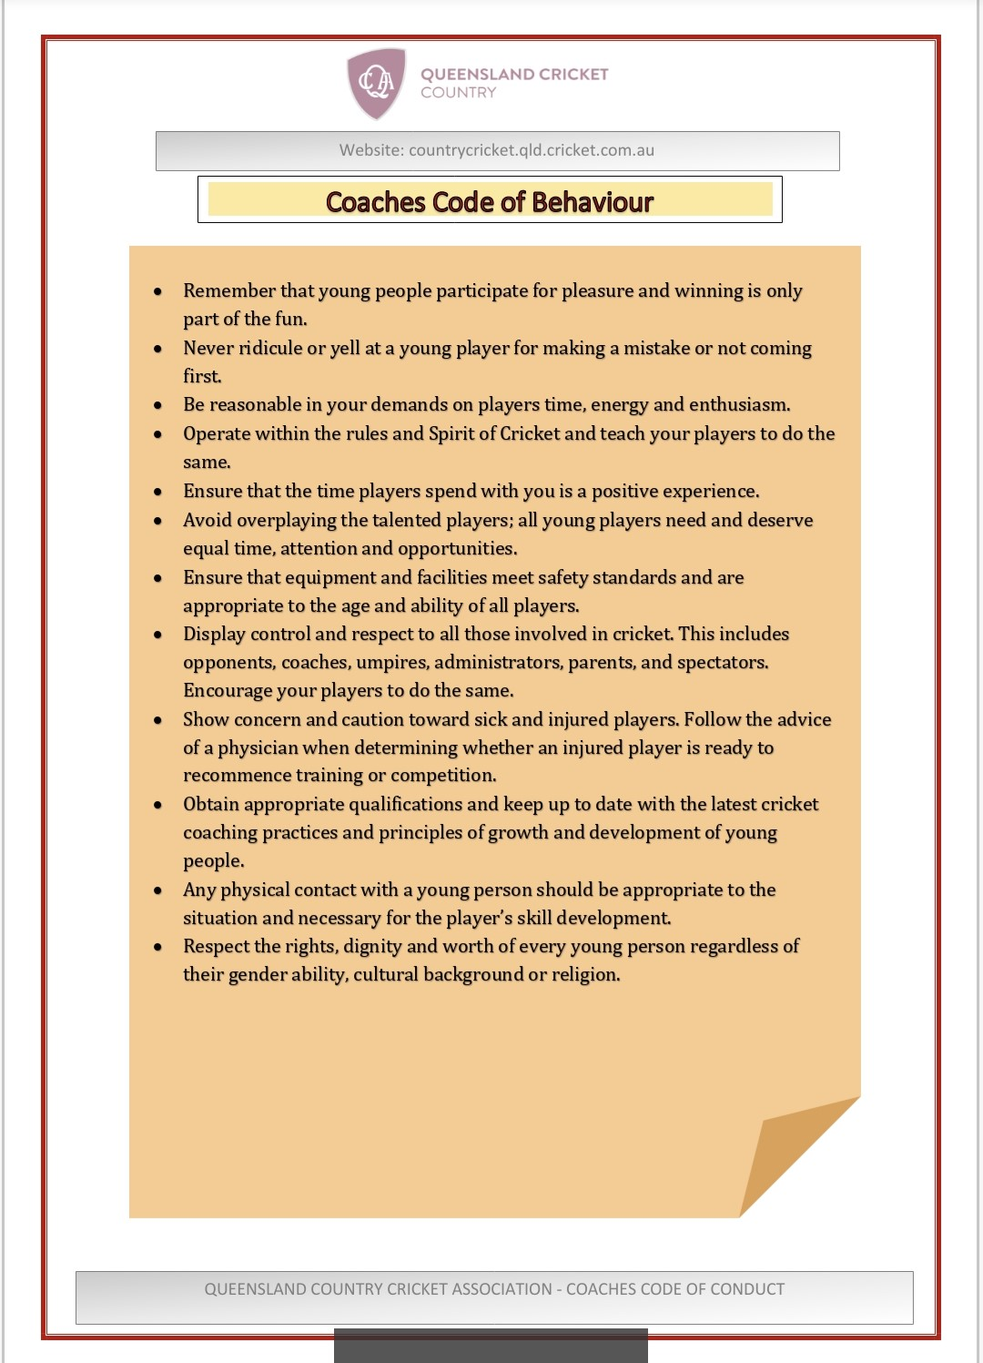

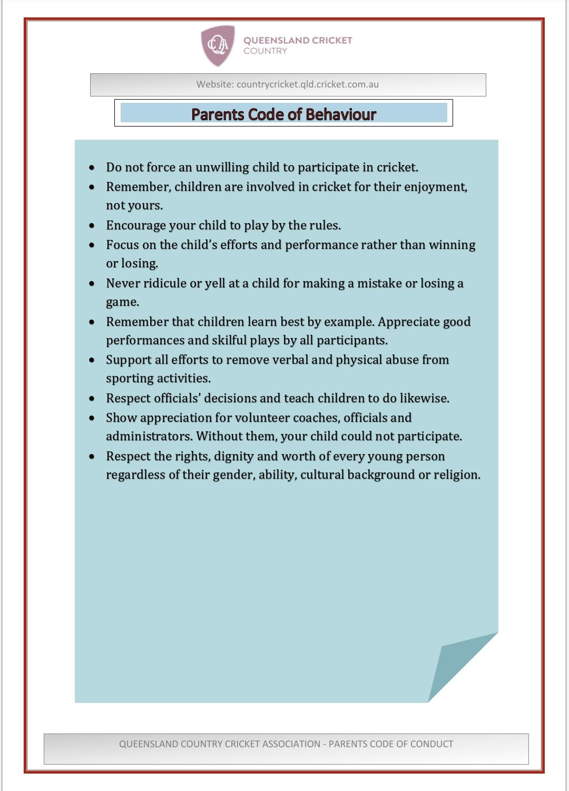

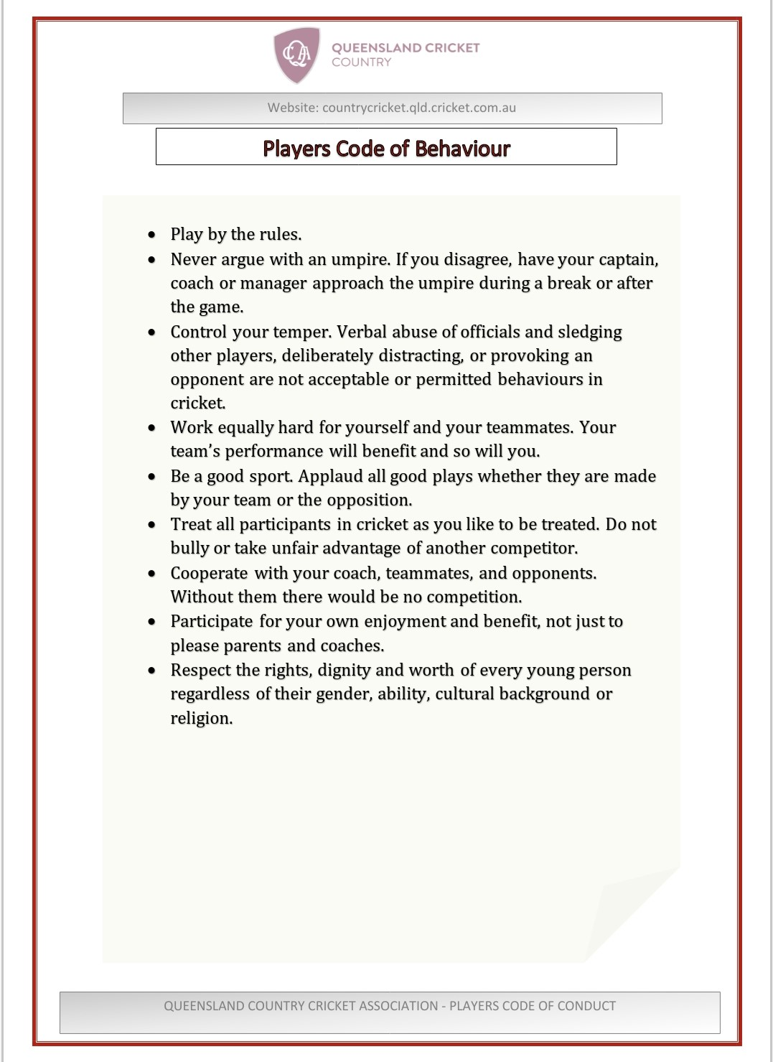

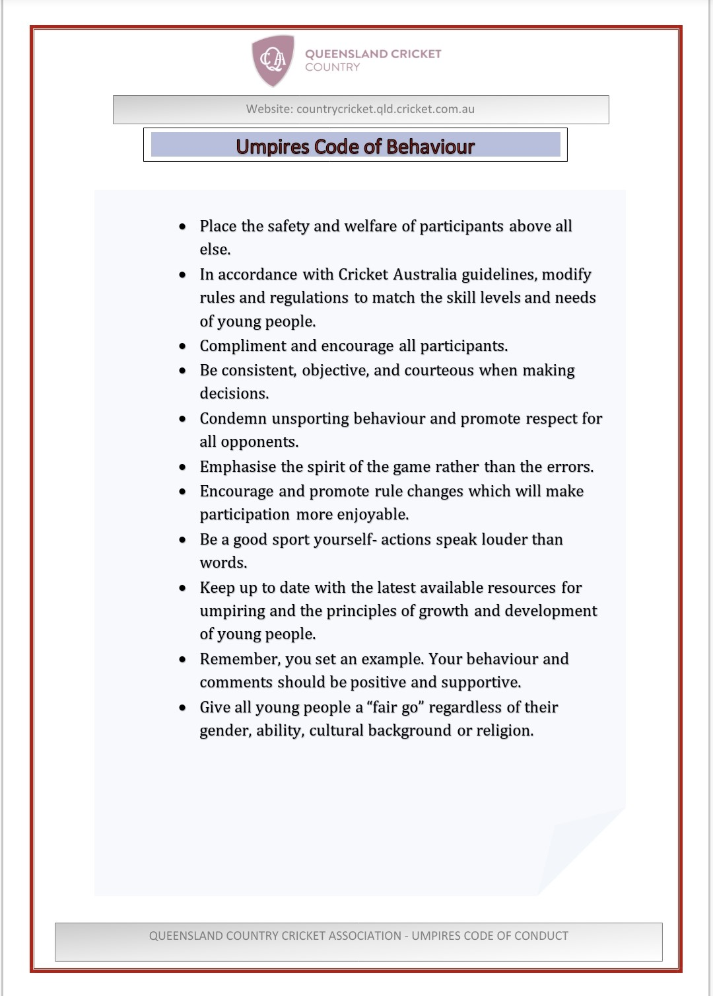

Attachment 3:
DUTY STATEMENTS

Coaches and managers role descriptions when complete


Attachment 4:

PROCEDURE FOR HANDLING ALLEGATIONS OF CHILD ABUSE

If you believe a child is in immediate danger or a life-threatening situation, contact the Police immediately on 000.

Fact sheets on reporting allegations of child abuse in different states and territories are available at www.playbytherules.net.au.

Queensland Country Cricket Association will treat any allegation of child abuse or neglect promptly, seriously and with a high degree of sensitivity.

All people working with Queensland Country Cricket Association in a paid or unpaid capacity have a duty to report any concerns to the appropriate authorities, following the steps outlined below.

Step 1: Receive the allegation

If a child or young person raises with you an allegation of child abuse or neglect that relates to them or to another child, it is important that you listen, stay calm and be supportive.

Do | Don’t
Make sure you are clear about what the child has  told you | Do not challenge or undermine the child
Reassure the child that what has occurred is not his or her fault | Do not seek detailed information, ask leading questions or offer an opinion.
Explain that other people may need to be told in order to stop what is happening. | Do not discuss the details with any person other than those detailed in these procedures.
Promptly and accurately record the discussion in writing. | Do not contact the alleged offender.

Step 2: Report the allegation

- Immediately report any allegation of child abuse or neglect, or any situation involving a child at risk of harm, to the police and/or the relevant child protection agency. You may need to make a report to both.

- Contact the relevant child protection agency or police for advice if there is any doubt about whether the allegation should be reported.

- If the allegation involves a person to whom this policy applies, then also report the allegation to the Queensland Country Cricket Association Member Protection Information Officer (“MPIO”) so that he or she can manage the situation.

Step 3: Protect the child and manage the situation

- The MPIO will assess the immediate risks to the child and take interim steps to ensure the child’s safety and the safety of any other children. This may include redeploying the alleged offender to a position where there is no unsupervised contact with children, supervising the alleged offender or removing/suspending him or her until any investigations have been concluded. Legal advice should be sought before any interim steps are made if the person is in paid employment with the Queensland Country Cricket Association.

- The MPIO will consider what services may be most appropriate to support the child and his or her parent/s.

- The MPIO will consider what support services may be appropriate for the alleged offender.

- The MPIO will put in place measures to protect the child and the alleged offender from possible victimization and gossip.

Step 4: Take internal action

- Up to three different investigations could be undertaken to examine allegations that are made against a person to whom this policy applies, including:

- a criminal investigation (conducted by the police)

- a child protection investigation (conducted by the relevant child protection agency)

- a disciplinary or misconduct inquiry/investigation (conducted by Queensland Country Cricket Association).

- Regardless of the findings of the police and/or child protection agency investigations, Queensland Country Cricket Association will assess the allegations to decide whether the alleged offender should return to his or her position, be dismissed, be banned or face any other disciplinary action.

- The MPIO of Queensland Country Cricket Association will consider all information relevant to the matter – including any findings made by the police, the child protection authority and/or court – and then set out a finding, recommend actions and the rationale for those actions.

- If disciplinary action is recommended, Queensland Country Cricket Association will follow the procedures set out in clause 8 of the Queensland Country Cricket Association Member Protection Policy.

- Queensland Country Cricket Association will provide the relevant government agency with a report of any disciplinary action it takes, where this is required.

Contact details for advice or to report an allegation of child abuse

Queensland
Queensland Police  Non-urgent police assistance  Ph: 131 444  www.police.qld.gov.au | Department of Communities  www.communities.qld.gov.au/childsafety  Ph: 1800 811 810

Attachment 5: REPORTING REQUIREMENTS AND DOCUMENTS

5A. RECORD OF COMPLAINT

Name of person receiving complaint |  | Date: / /
Complainant’s Name | Over 18 Under 18
Complainant’s contact details | Phone:  Email:
Complainant’s role/status in Club | Administrator (volunteer) Parent  Athlete/player Spectator  Coach/Assistant Coach Support Personnel  Employee (paid) Other  Official ………………………………….
Name of person complained about | Over 18 Under 18
Person complained about role/status in Club | Administrator (volunteer) Parent  Athlete/player Spectator  Coach/Assistant Coach Support Personnel  Employee (paid) Other  Official ………………………………….
Location/event of alleged issue
Description of alleged issue

Nature of complaint (category/basis/grounds)  Can tick more than one box | Harassment or Discrimination  Sexual/sexist Selection dispute Coaching methods  - Sexuality Personality clash Verbal abuse  - Race Bullying Physical abuse  - Religion Disability Victimisation  - Pregnancy Child Abuse Unfair decision  - Other …………………………………………………………………
What they want to happen to fix issue
Information provided to them
Resolution and/or action taken
Follow-up action

5B. CONFIDENTIAL RECORD OF CHILD ABUSE ALLEGATION

Before completing, ensure the procedures outlined in Procedure for Handling Allegations of Child Abuse have been followed and advice has been sought from the relevant government agency and/or police.
Complainant’s Name (if other than the child) |  | Date Formal Complaint Received: / /
Role/status in sport
Child’s name |  | Age:
Child’s address
Person’s reason for suspecting abuse
(e.g. observation, injury, disclosure)
Name of person complained about
Role/status in sport | Administrator (volunteer) Parent  Athlete/player Spectator  Coach/Assistant Coach Support Personnel  Employee (paid) Other  Official ………………………………….
Witnesses  (if more than 3 witnesses, attach details to this form) | Name (1):  Contact details:  Name (2):  Contact details:  Name (3):  Contact details:
Interim action (if any) taken (to ensure child’s safety and/or to support needs of person complained about)
Police contacted | Who:  When:  Advice provided:
Government agency contacted | Who:  When:  Advice provided:
President and/or MPIO contacted | Who:  When:
Police and/or government agency investigation | Finding:
Internal investigation (if any) | Finding:
Action taken
Completed by | Name:  Position:  Signature: / /
Signed by | Complainant (if not a child)

This record and any notes must be kept in a confidential and safe place and provided to the relevant authorities (police and government) should they require them.
Attachment 6: Child and Youth Risk Management Strategy Checklist / Action Plan Template
(Blue Card system minimum requirements from https://www.bluecard.qld.gov.au/risk-management.html)

Mandatory Requirements | Does this already exist?
Mandatory Requirements | Yes | Location and/or amendments | No | Resources required | By whom/when?
1. A statement of commitment to the safety and wellbeing of children and the protection of children from harm | x | Member Protection Policy |  | Included in policy
2. A code of conduct for interacting with children and young people | x | Member Protection Policy (attachment 2) |  | Included in policy
3. Written procedures for recruiting, selecting, training and managing staff and volunteers |  | Association/Club documents |  | - Should be tailored for your Club or Association  - Volunteer management resources: https://www.volunteeringqld.org.au/resources/volunteer-management#orientate-train-volunteers
4. Policies and procedures for handling disclosures or suspicions of harm, including reporting guidelines | x | Member Protection Policy |  | - Included in policy  - MPIO training
5. A plan for managing breaches of the risk management strategy | x | Member Protection Policy |  | - Included in policy  - MPIO training
6. Policies and procedures for managing compliance with the blue card system | x | Member Protection Policy |  | - Included in policy (7.1.3)  - Blue card register template at http://www.bluecard.qld.gov.au/risk-management.html - ‘employee register xls’.]
7. Risk management plans for high risk activities and special events* |  | Association/Club documents |  | Risk management plan template available at https://www.bluecard.qld.gov.au/risk-management.html - “Risk management plan for high risk activities and special events template”
8. Strategies for communication and support | x | Member Protection Policy |  | - Attachment 1B (member protection declaration)  - MPIO training

